## Global Electronics Retailer: Interactive Revenue & Operations Analysis

**Context**

You’ve been hired as a **Data Analyst at Maven Electronics**, a global retailer selling consumer electronics online and in-store.  
Since 2020, the company’s revenue has been declining. Management needs a consolidated data model and interactive dashboard to explore trends and identify performance drivers.

**Project Objectives**

| **#** | **Objective** | **Key Tasks Completed** |
| --- | --- | --- |
| **1** | Profile and Prepare the Data | Imported and cleaned multiple CSVs (Sales, Customers, Products, Stores, Exchange Rates), added a Calendar table, handled missing values, standardized formats, added derived columns like Customer Age and Delivery Time. |
| **2** | Build a Relational Model | Connected fact and dimension tables via 1:* relationships, built composite ExchangeKey, split Products table into Category/Subcategory hierarchies, hid foreign keys. |
| **3** | Enrich and Explore | Added DAX measures for KPIs (Orders, Revenue, AOV, Delivery Time), performed exploratory analysis by time, store, category, and age group. |
| **4** | Build Interactive Report | Designed a KPI-driven Excel dashboard with slicers, charts, and consistent formatting for leadership analysis. |

**Objective 1: Profile & Prepare Data**

**Steps:**

* Connected to CSVs via Power Query and performed column profiling.
* Identified **26,326 orders** from **2016 to 2021**.
* Found that **only online store (Store ID 0)** had delivery dates — confirmed via Stores table.
* Added TransactionKey (Index Column) as unique ID.

**Key Findings:**

* 8 product categories, 32 subcategories.
* 67 stores across 8 countries (1 online).
* 15,266 customers — ~45% based in USA.
* Exchange Rates table used to normalize revenue to USD.
* Built a contiguous **Calendar Table** with derived time fields (Day Name, Month, Quarter, etc.).
* Derived fields:
  + Customer Age
  + Age Range (Senior, Adult, Young Adult)
  + Delivery Time (Days)

**Objective 2: Build a Relational Model**

**Relationships:**

* Sales → Customers, Sales → Stores, Sales → Products, Sales → Calendar
* Created ExchangeKey = Date + Currency to connect Sales ↔ Exchange Rates
* Split Products table into **Category** and **Subcategory** dimension tables.
* Verified model integrity in Power Pivot and hid redundant foreign keys.

**Schema Summary (Star Model):**

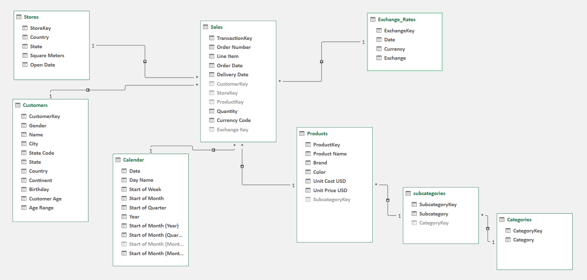

**Objective 3: Enrich & Explore the Data**

**Created a “Measures” Table** for organized DAX metrics:

Total Orders = DISTINCTCOUNT(Sales[Order Number])

Total Revenue(USD) = SUMX(Sales,[Quantity]*RELATED(Products[Unit Price USD]))

Total Revenue (Local) = SUMX(Sales,[Quantity]*(RELATED(Products[Unit Price USD]))*RELATED(Exchange_Rates[Exchange]))

Average Order Value = DIVIDE([Total Revenue (USD)], [Total Orders])

Average Delivery Time = CALCULATE(AVERAGEX(Sales,[Delivery Date]-[Order Date]),Sales[StoreKey]=0)

**Key Insights:**

* Total Revenue (USD): **$55.8M**
* Online Store alone: **$11.4M (≈20%)**
* Home Appliances: Highest AOV ($2,078)
* Games & Toys: Lowest AOV ($118)
* Average delivery time: **4.5 days**, improved from **7.3 days (2016)** → **3.8 days (2021)**
* Revenue & orders both dropped significantly in **April 2020**, never fully recovered.
* Seasonal patterns with recurring April dips.

**Objective 4: Build Interactive Report**

**Dashboard Features:**

* **KPI Cards:** Total Orders, Total Revenue, AOV, Avg Delivery Time.
* **Line Chart:** Revenue trend by month (2016–2021).
* **Bar Chart:** Revenue by Product Category.
* **Slicers:** Year & Store (connected to all visuals).
* **Design Polish:** Consistent color palette, currency formatting, clear hierarchy.

**Dashboard Insights:**

* **Revenue peaks** before April each year → possible seasonal event.
* **April 2020 dip** correlates with onset of global disruptions.
* **Computers** and **Home Appliances** dominate post-2018 sales.
* **Delivery times** continuously improved — strong operational gain.

**Recommendations for Next Steps:**

* Deep dive into **April seasonality** and **post-2020 decline causes**.
* Add **Profit** and **Cost** data for margin analysis.
* Consider **Geo-level analysis** using country-level store performance.
* Analyze **Customer Cohorts** to study loyalty/retention trends.

**💡 Tools & Techniques Used**

| **Stage** | **Tools** | **Techniques** |
| --- | --- | --- |
| Data Preparation | Excel Power Query | Data cleaning, profiling, feature engineering |
| Data Modeling | Power Pivot | Relationship management, star schema |
| Analysis | DAX | KPI calculation, aggregation logic |
| Visualization | Excel Charts, Slicers | Dashboard design, interactivity, storytelling |